**Cancer Care App 1.0**

**User Manual**

**Authors: Alvaro Villa**

**Kyle Roque**

Table of Contents

Account Login 3

Account Creation 3

Home Page 3

Scheduler 4

Resources 4

Add Resource 5

Inbox 5

Message Detail 6

Alerts 6

Alert Detail 7

Compose Message 7

Forums 8

Forum Detail Page 8

Add Post 9

Events 9

Event Detail Page 10

Create Event 10

Personal Profile 11

Medical Profile 11

My Team 12

Add Contact 12

Support 13

View Users 13

View Posts 14

View Events 14

View Resources 15

Account Logout 15

**Account Login**

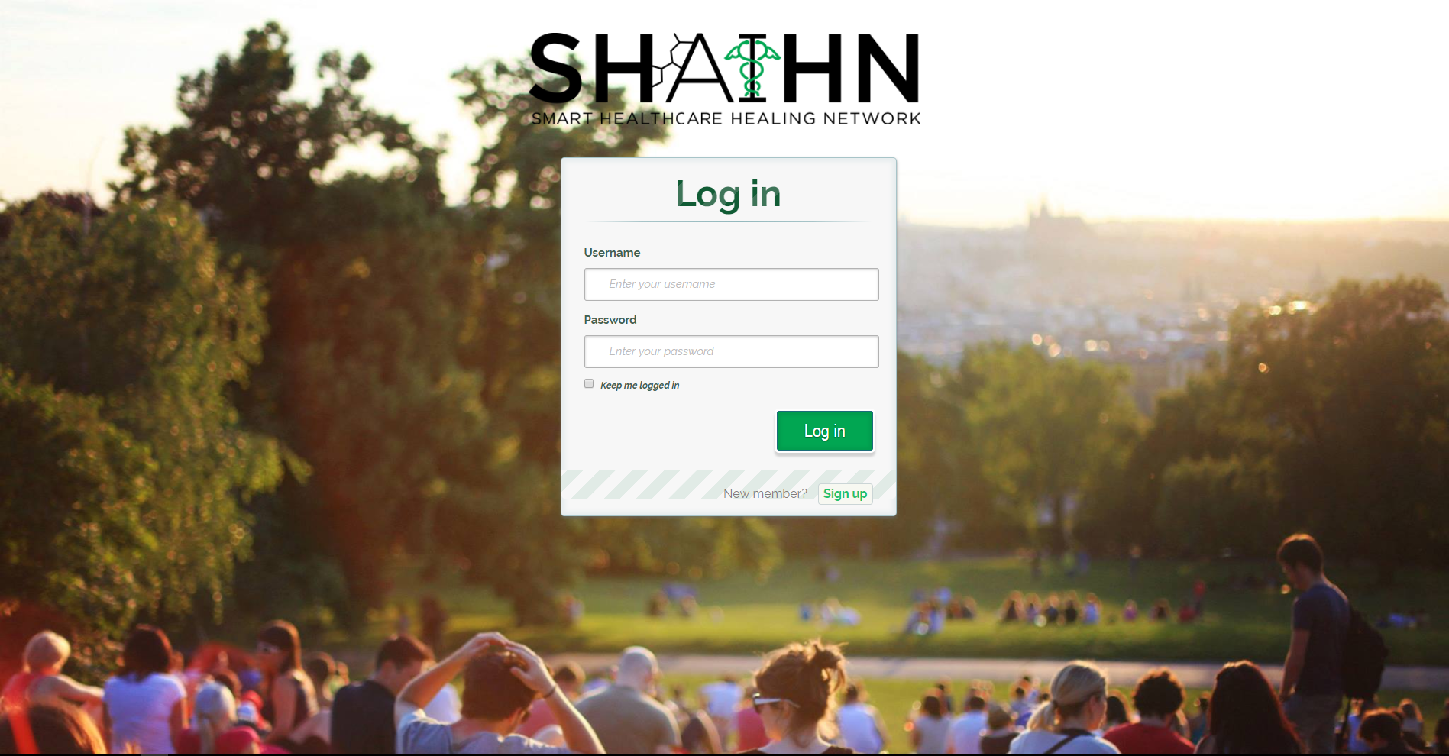

Use your credentials from when you created your account. If you haven’t yet created an account, click on the Sign up button.

**Account Creation**

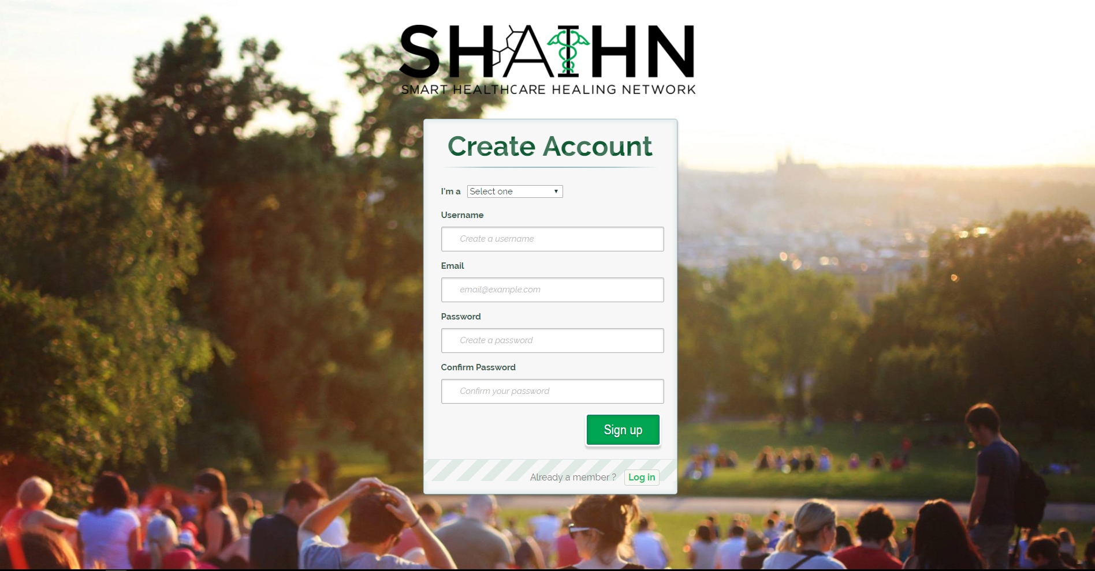

Fill in all the fields and select the type of user you are (health care provider or patient/caregiver). The first user becomes an admin.

**Home Page**

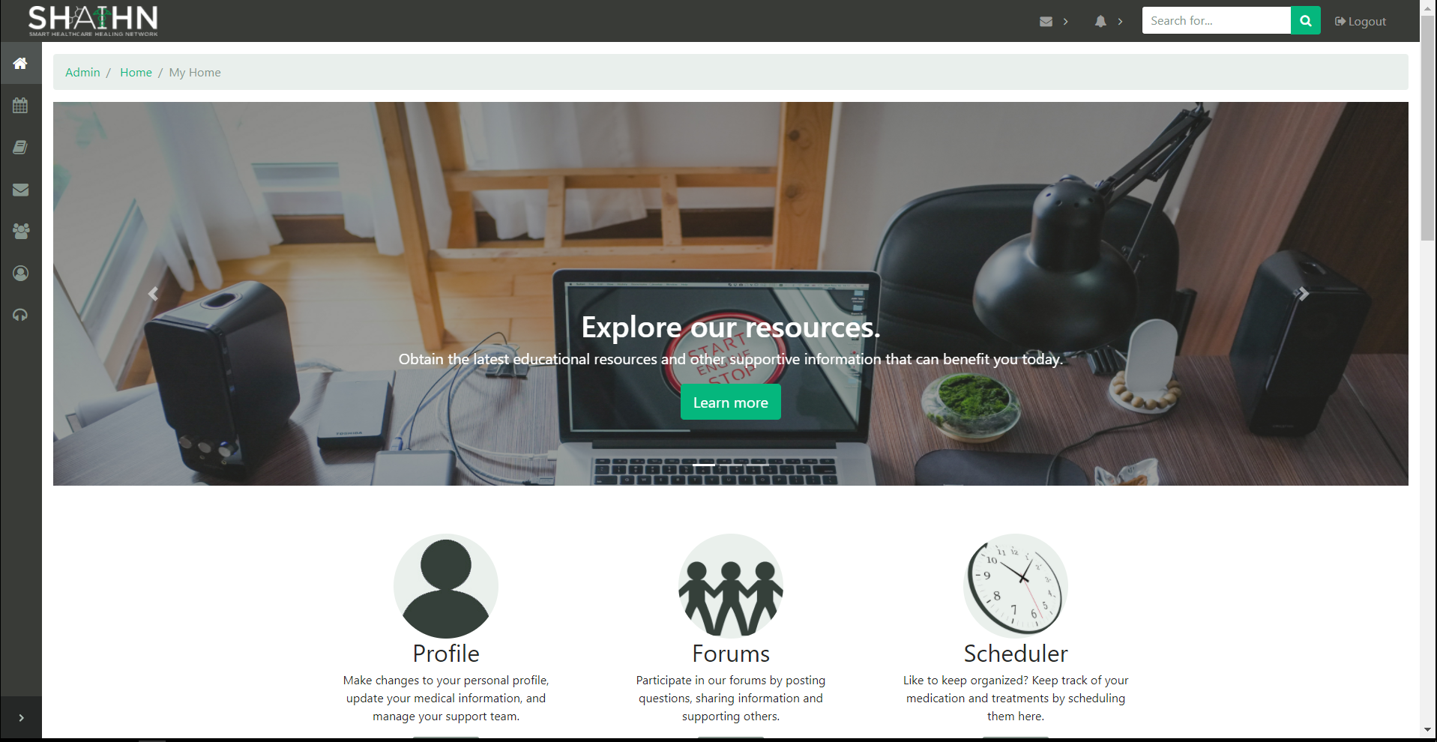

navigate anywhere in the site from this page.

**Scheduler**

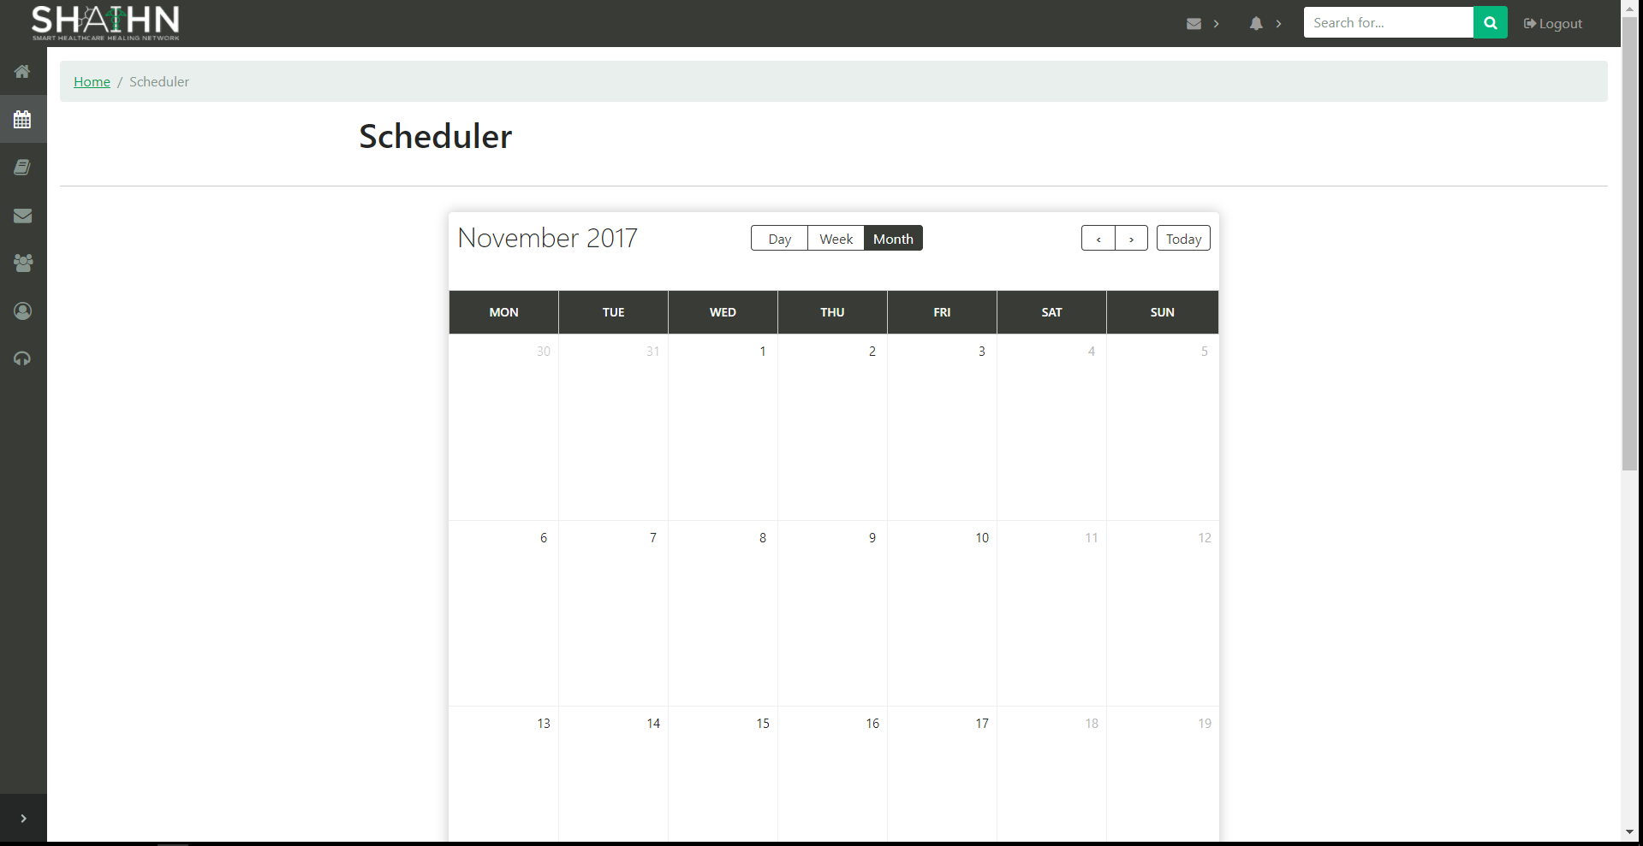

Add appointments or medication reminders by either dragging or selecting dates and writing in the dialog box that appears. (Front-end only)

**Resources**

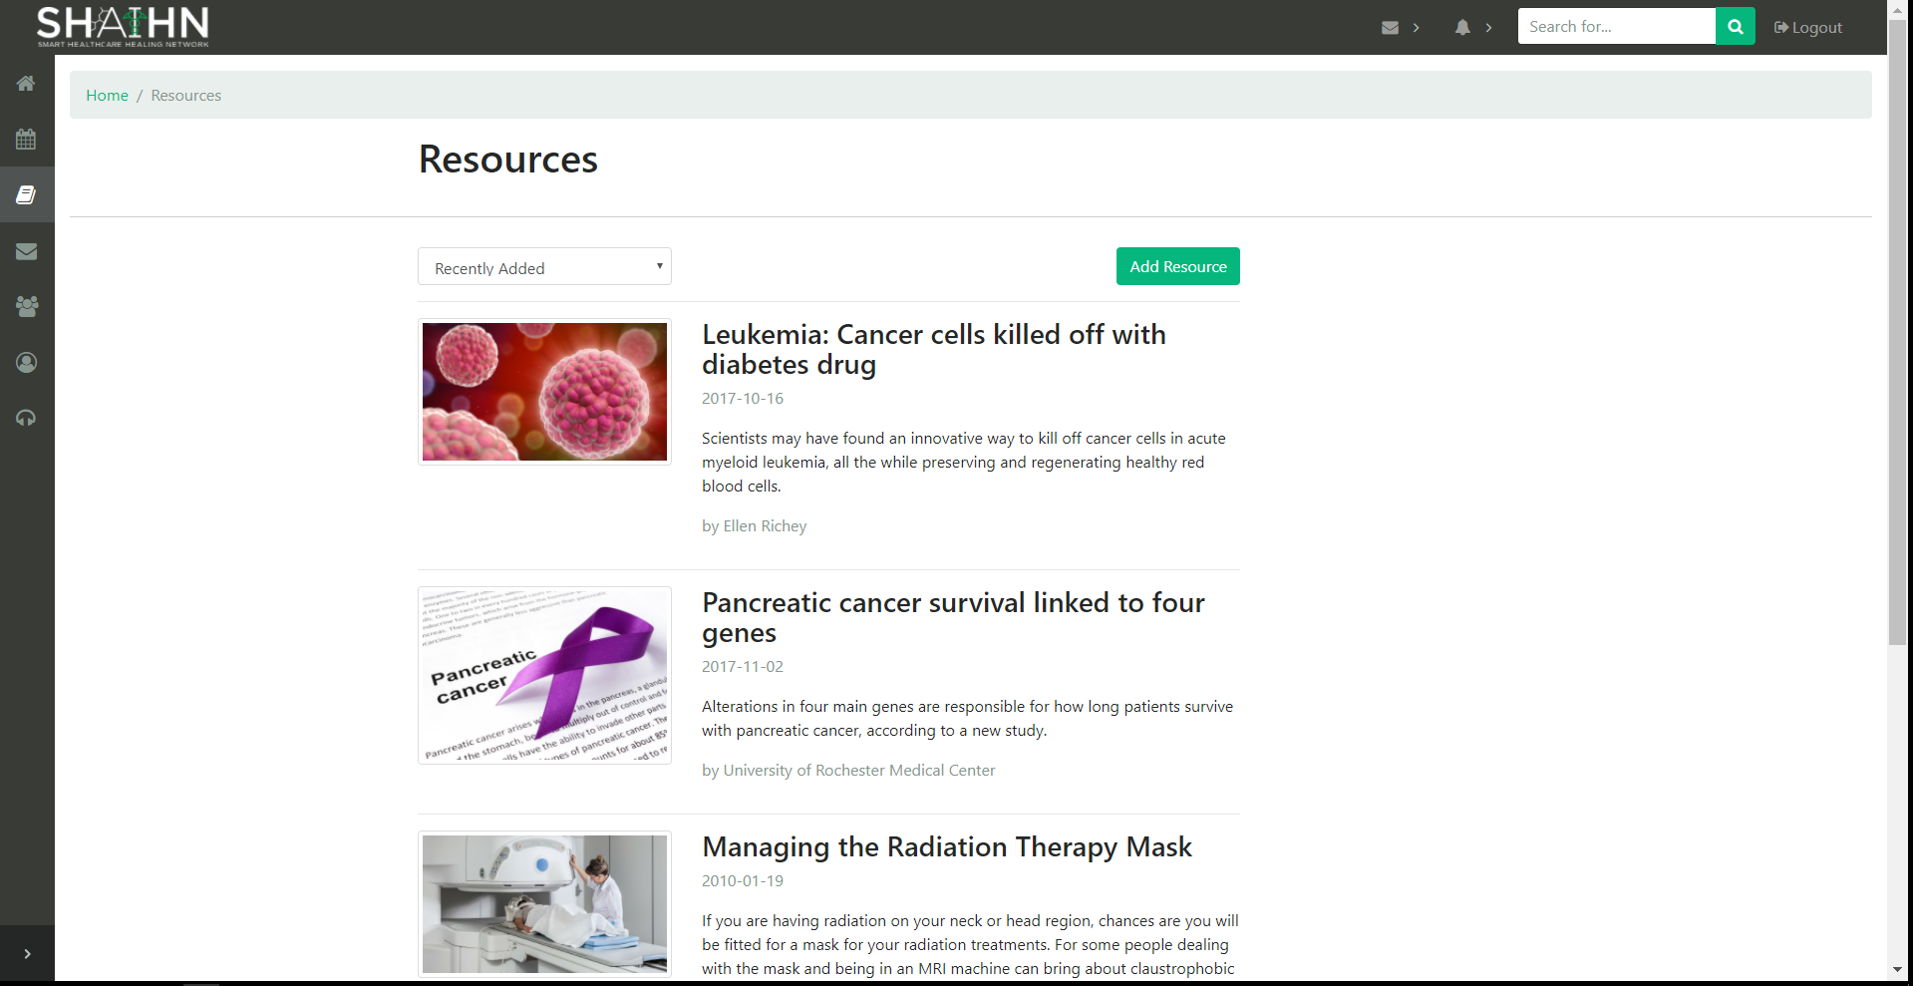

A list of resources. Clicking on a resource takes you to the article.

**Add Resource**

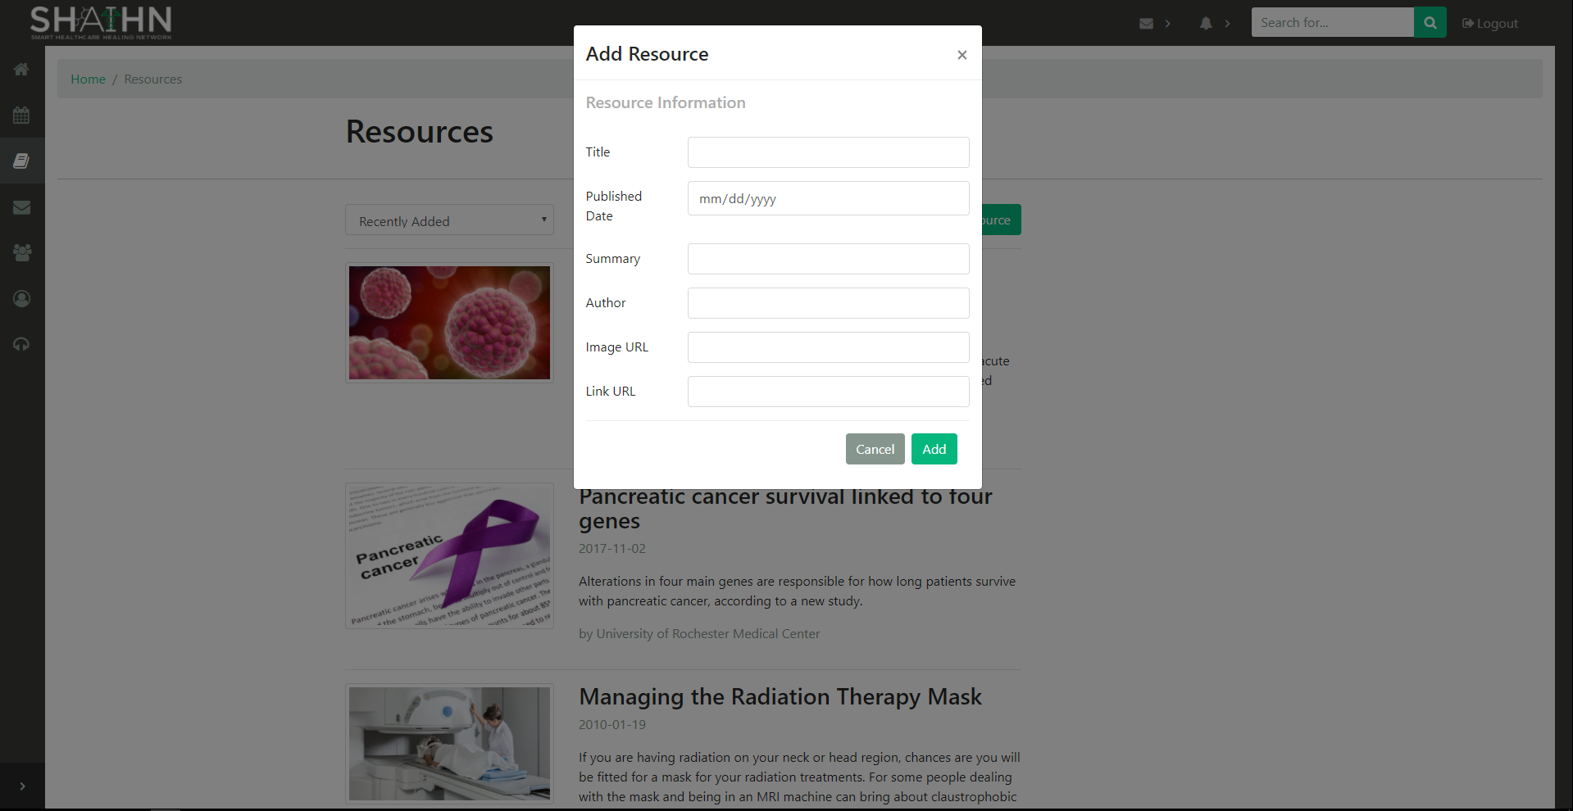

Feature only accessible by admins or health care providers. Fill in all the information to add the resource.

**Inbox**

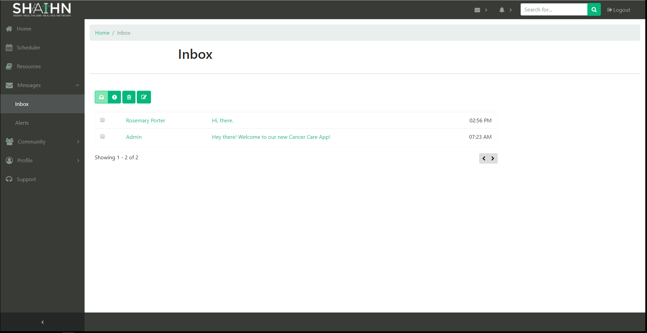

List of messages received. (Front-end only)

**Message Detail**

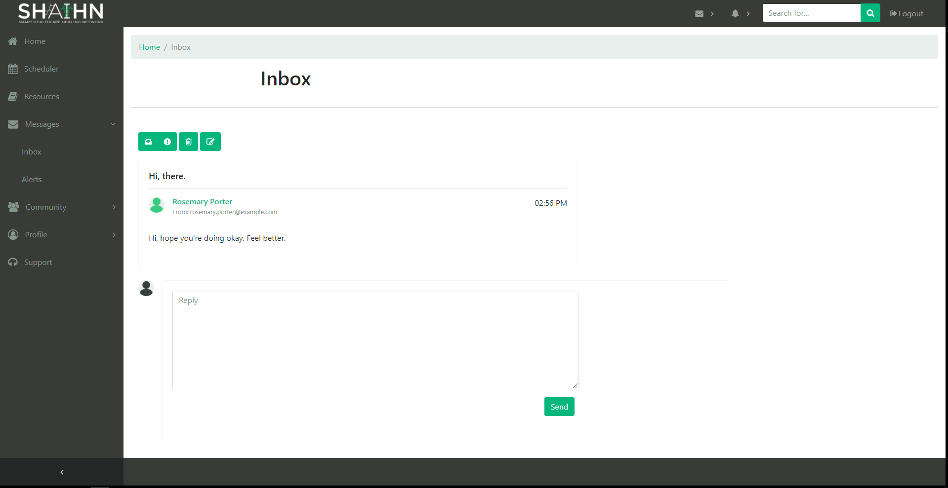

Shows the message body. Type in the textbox and click send to reply to the message. (Front-end only)

**Alerts**

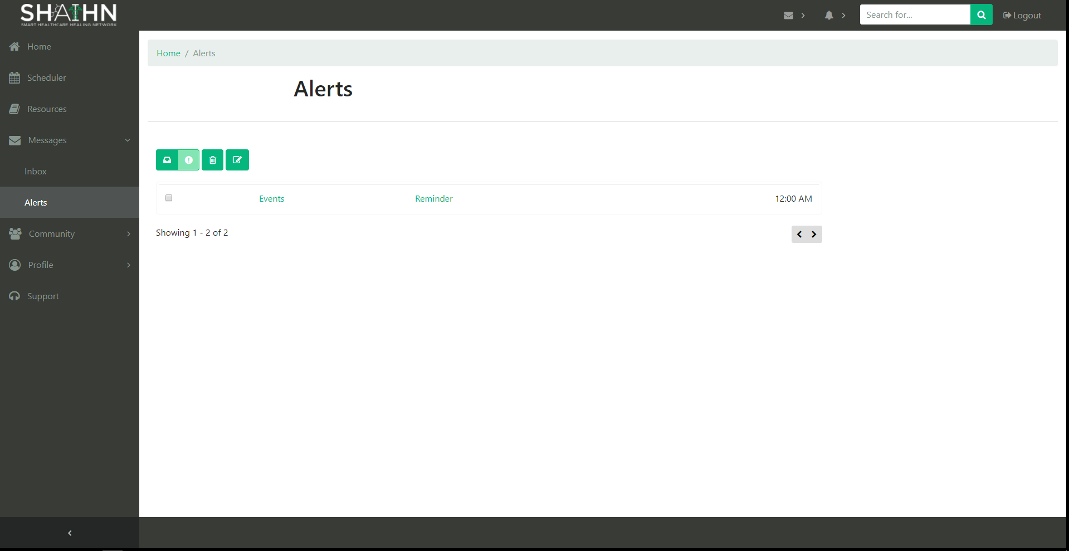

List of Alerts received. (Front-end only)

**Alert Detail**

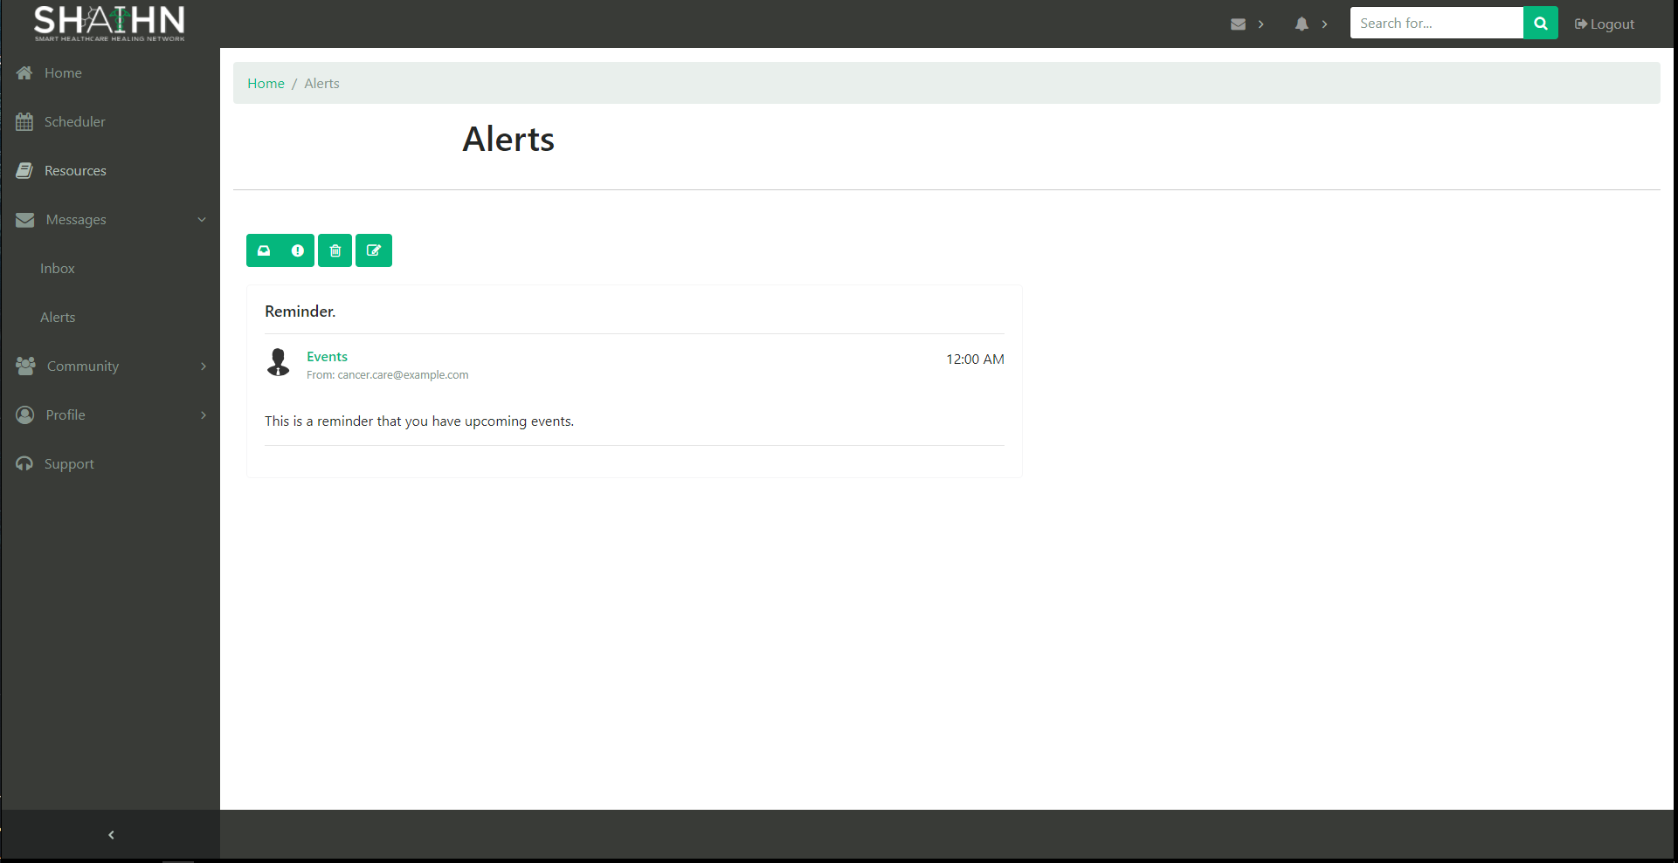

Shows the alert body. (Front-end only)

**Compose Message**

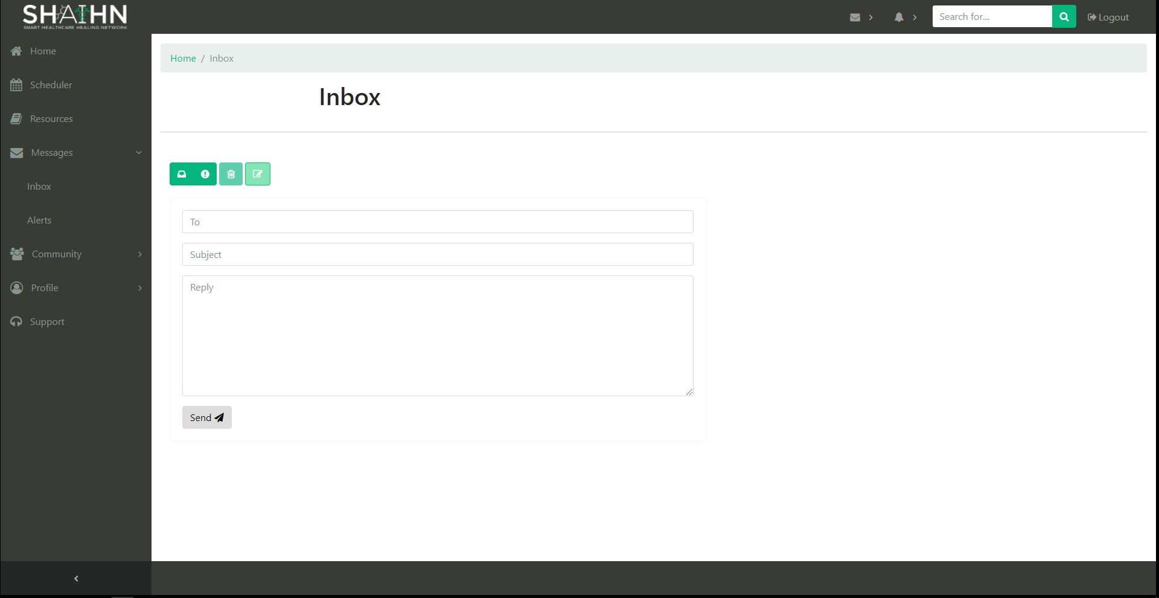

Fill in fields with email of user message is for, subject of message, and the message body. Then click send. (Front-end only)

**Forums**

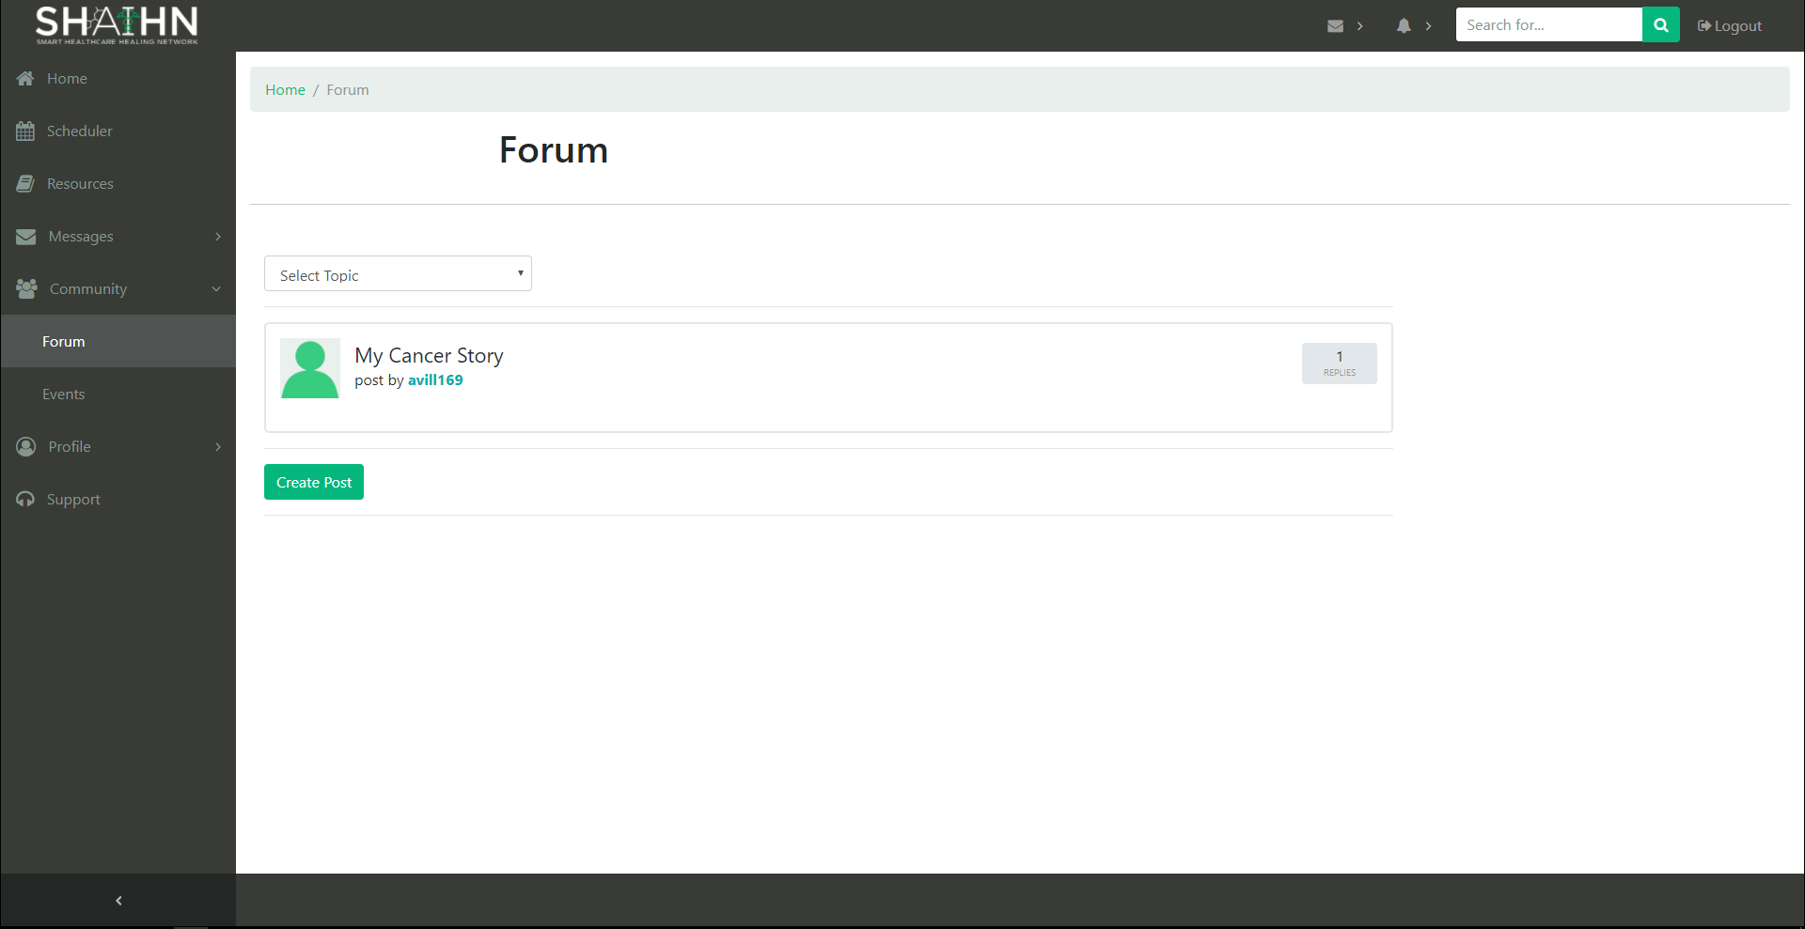

List of posts created by users.

**Forums Detail Page**

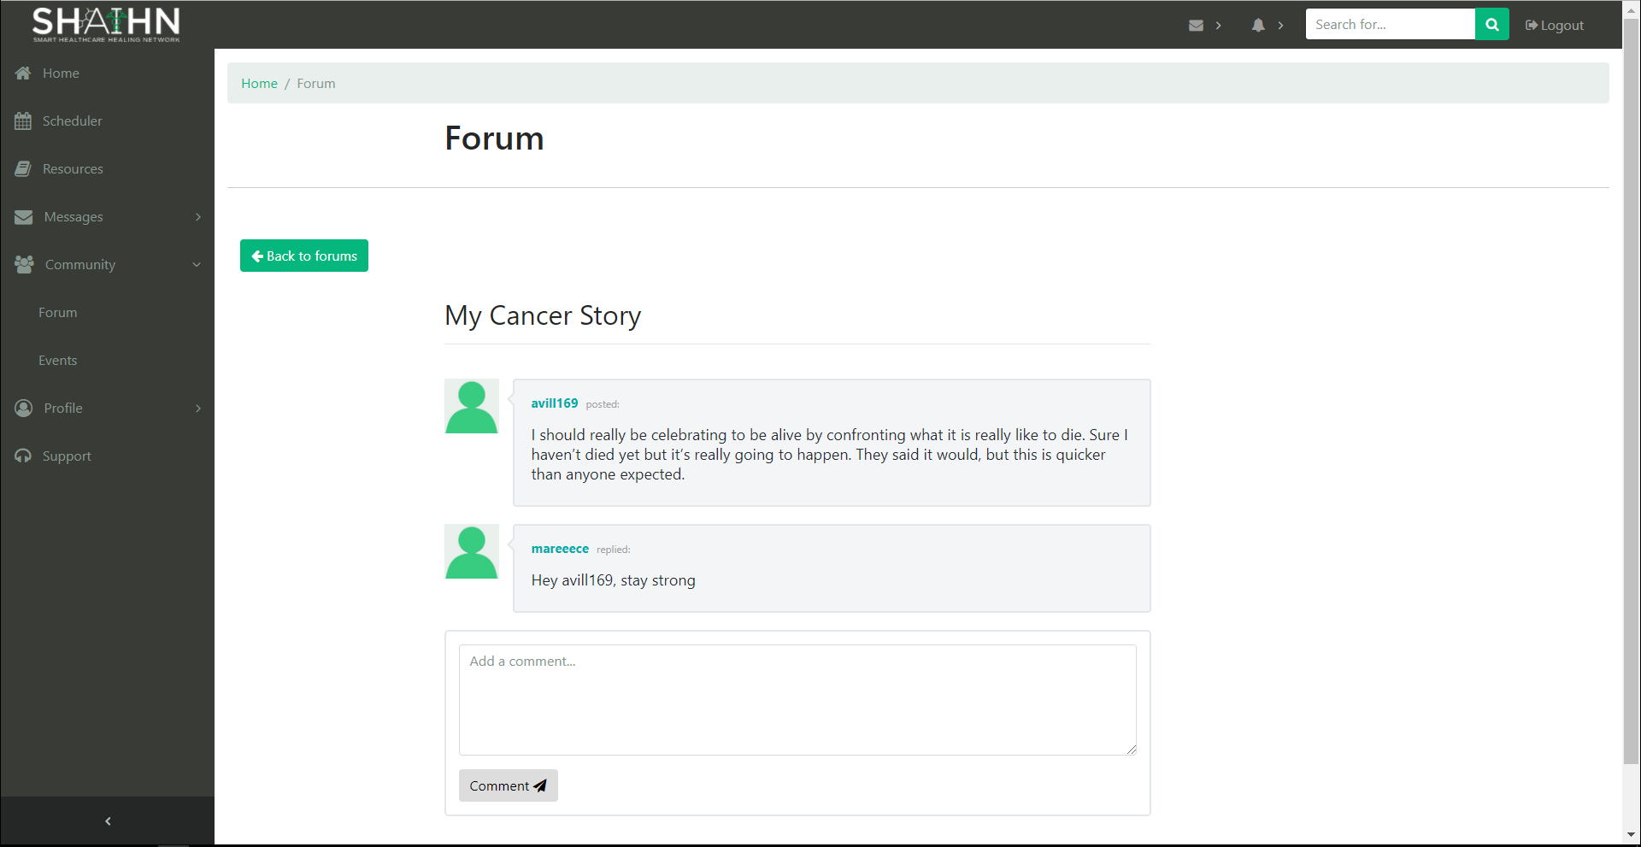

Shows post detail and allows a user to comment on the post. Type comment in textbox and click Comment.

**Add Post**

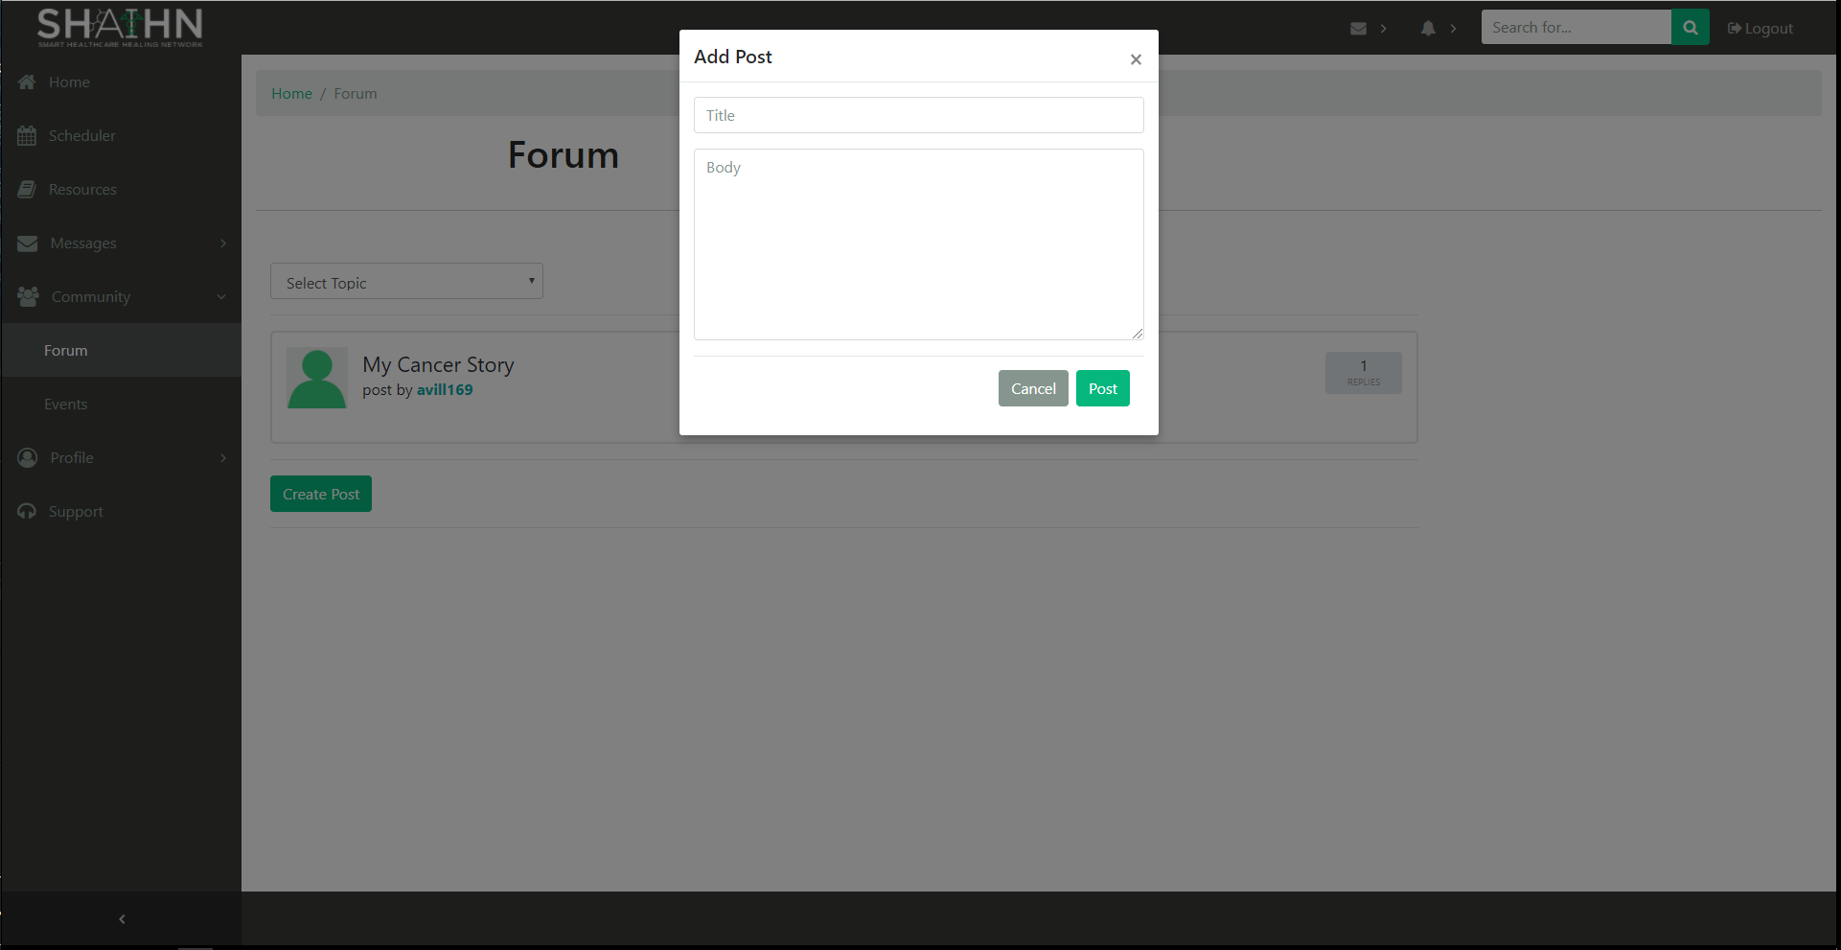

Each user can add a post by clicking Create Post. Fill in the field with a title and the post body, then click Post. To cancel, click cancel.

**Events**

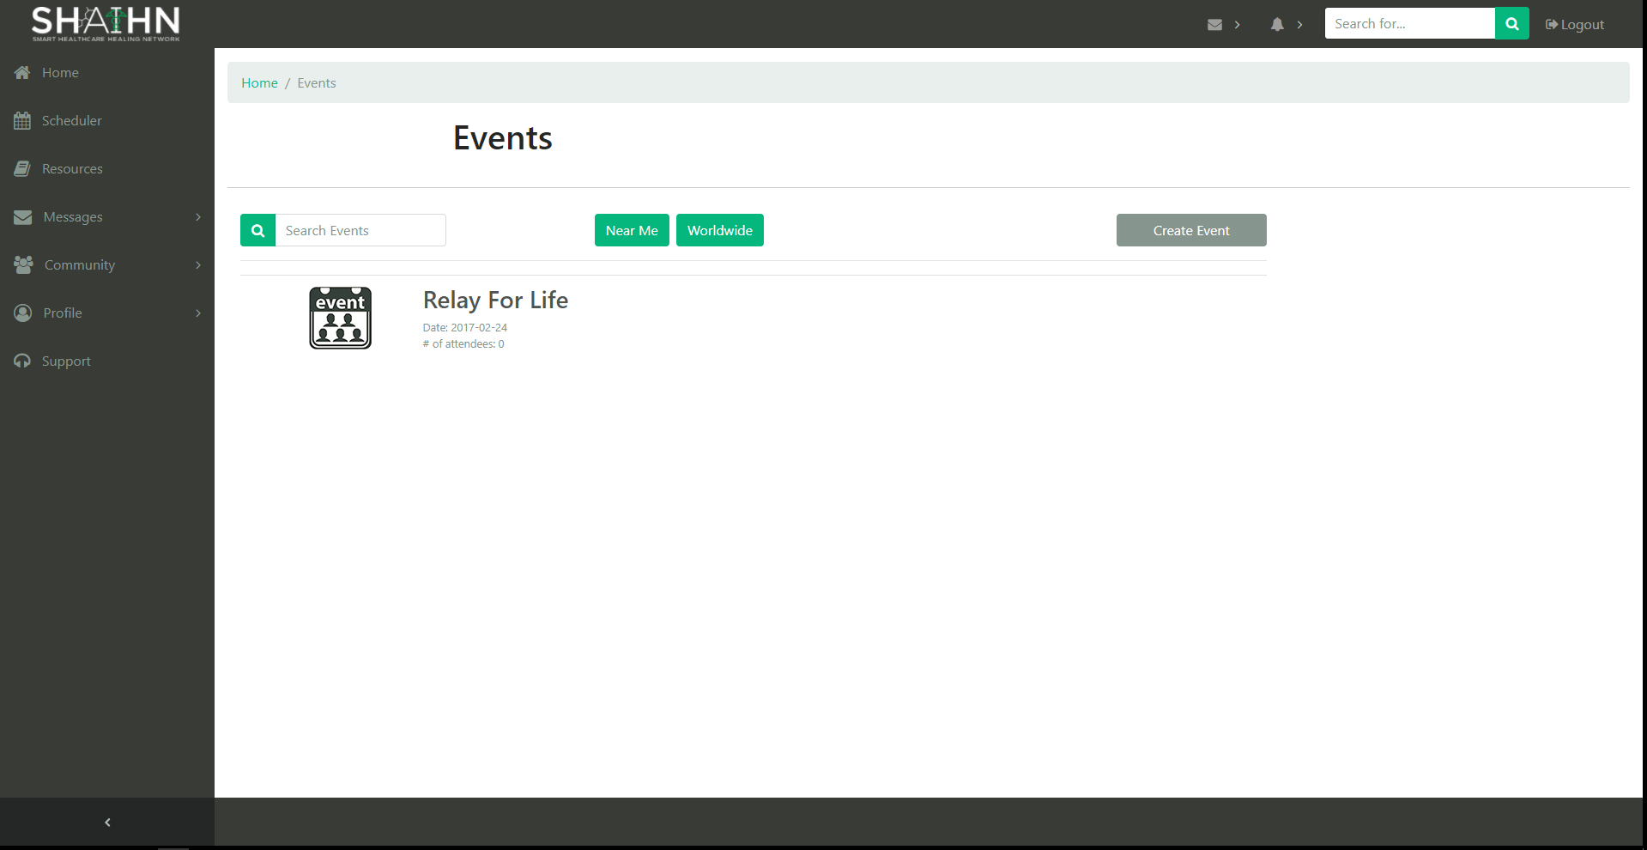

Shows list of events.

**Event Detail Page**

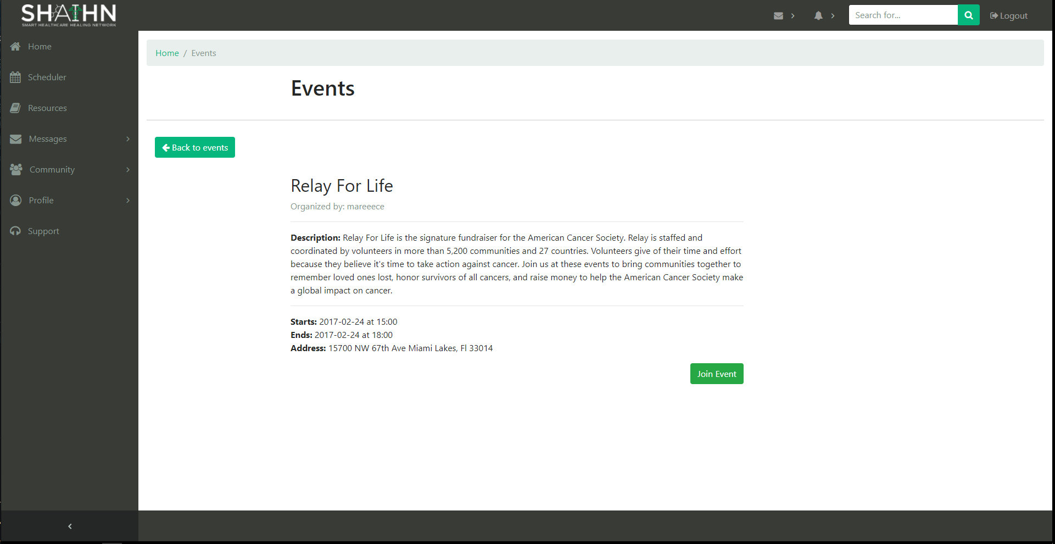

The detail page of an event. To join an event, click Join Event. User is redirected back to Events page if they clicked ‘Join Event’ or ‘Back to events’.

**Create Event**

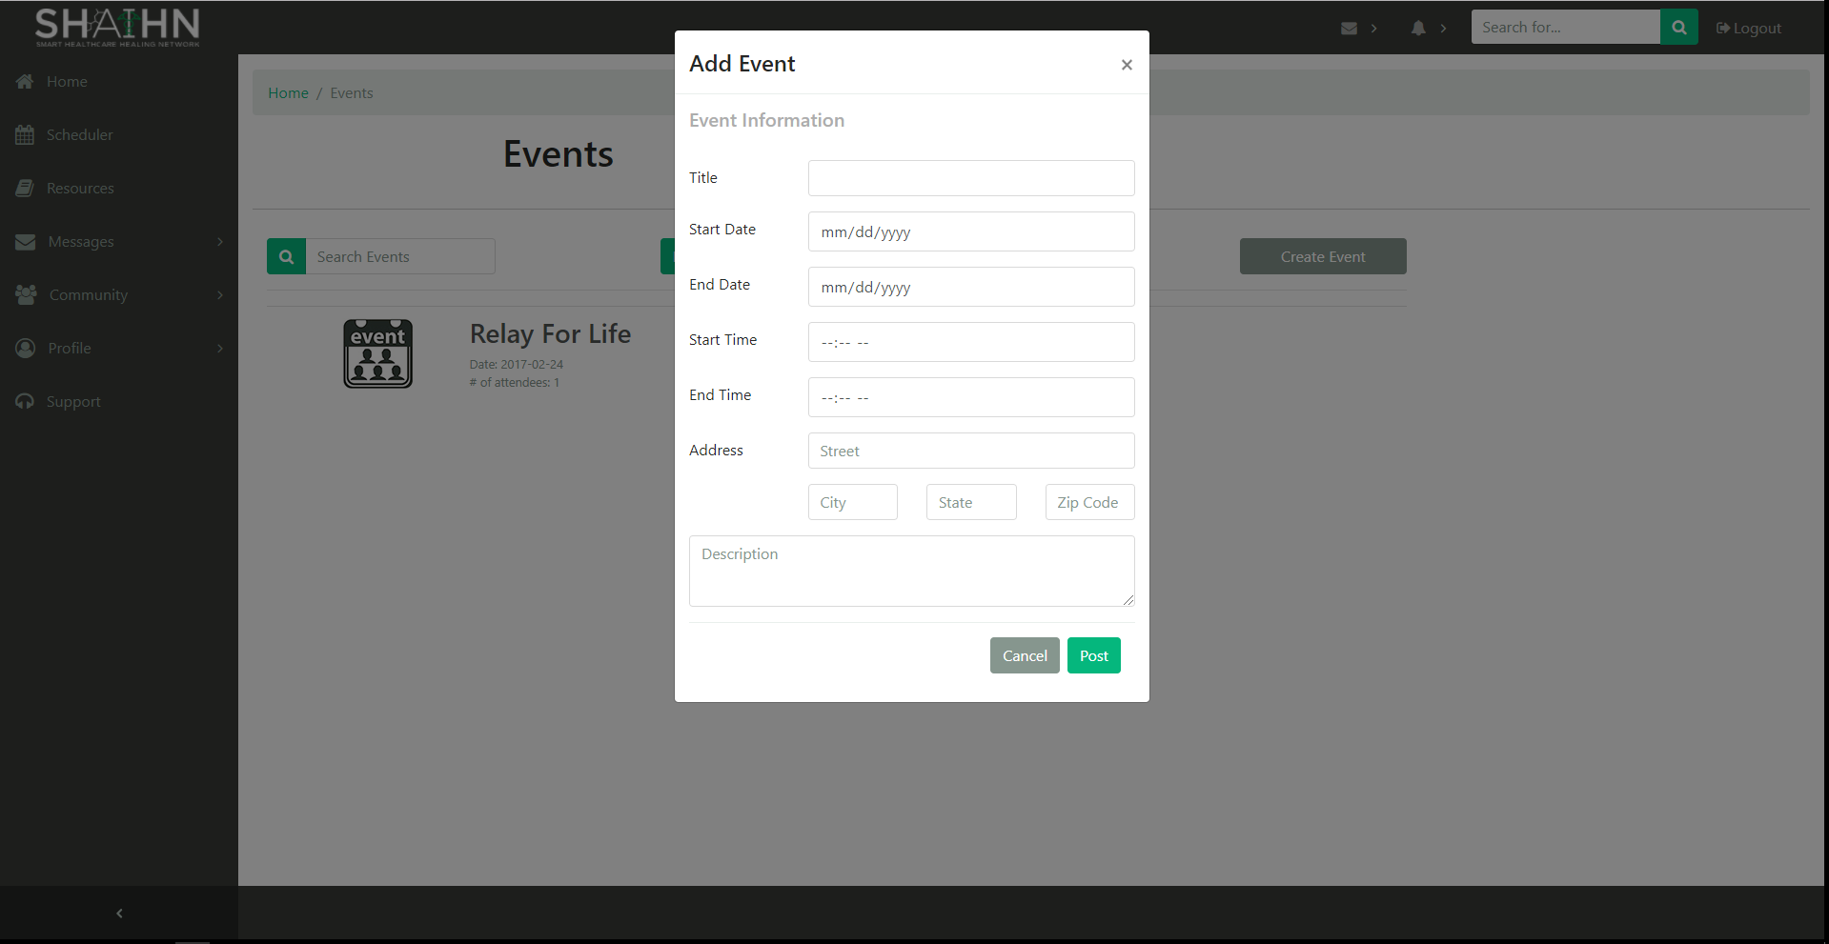

Each user can create an event. Fill in the fields, then click ‘Post’ to create the event. ‘Cancel’ closes the form.

**Personal Profile**

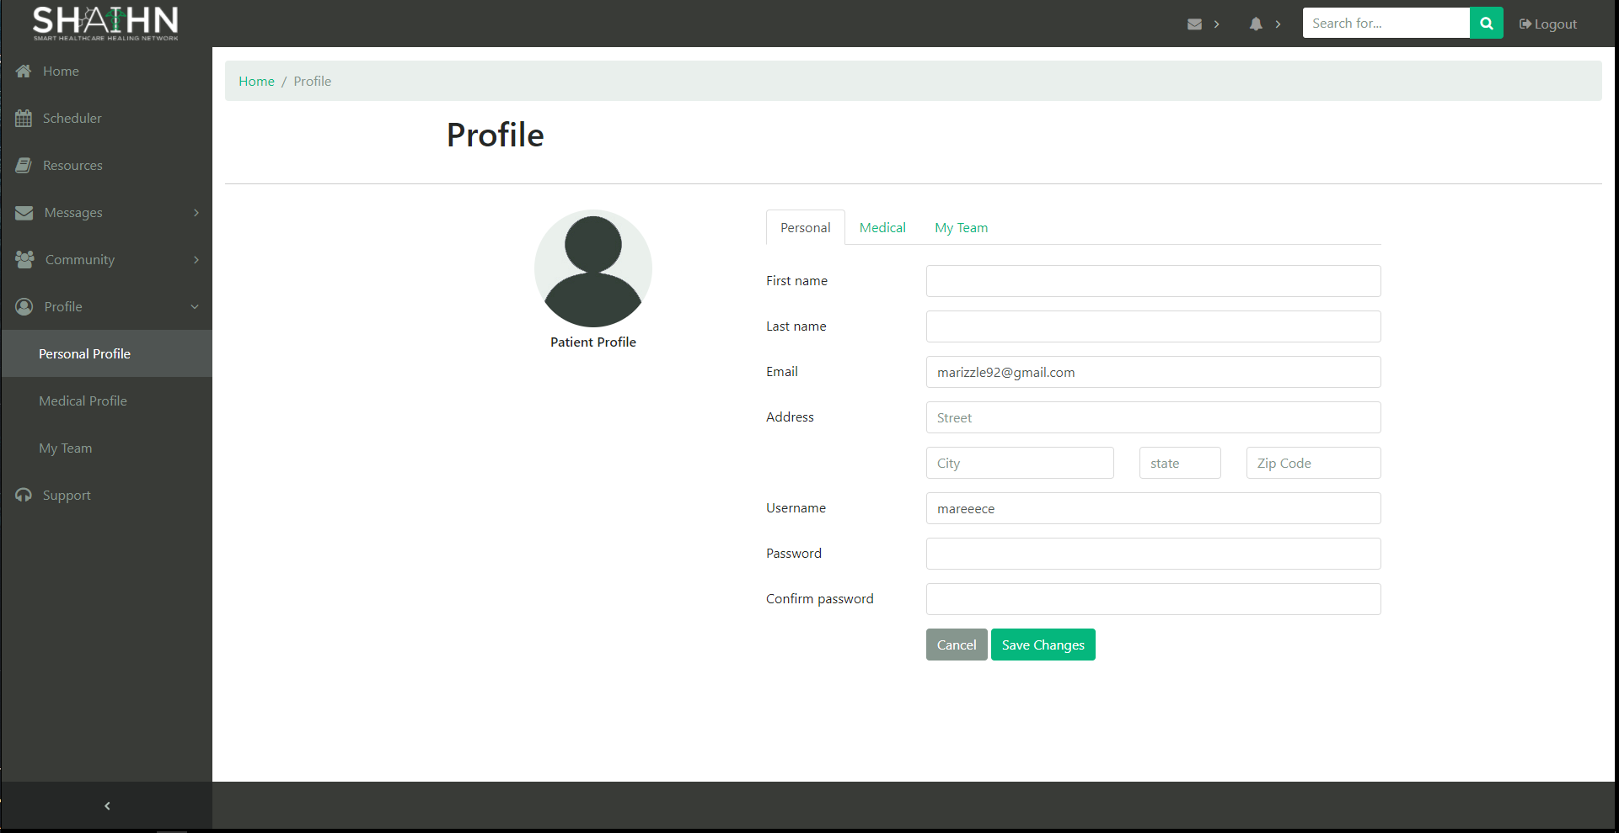

Users can update their personal information here. Fill in fields and click ‘Save Changes’.

**Medical Profile**

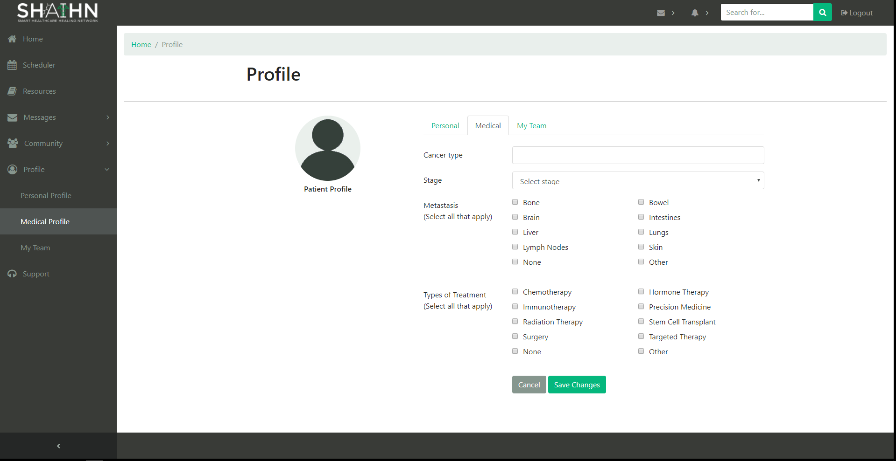

Users can update their medical information here. Fill in fields and click ‘Save Changes’. These are only fields related to a patient. We have not yet implemented a custom view for a healthcare provider's information.

**My Team**

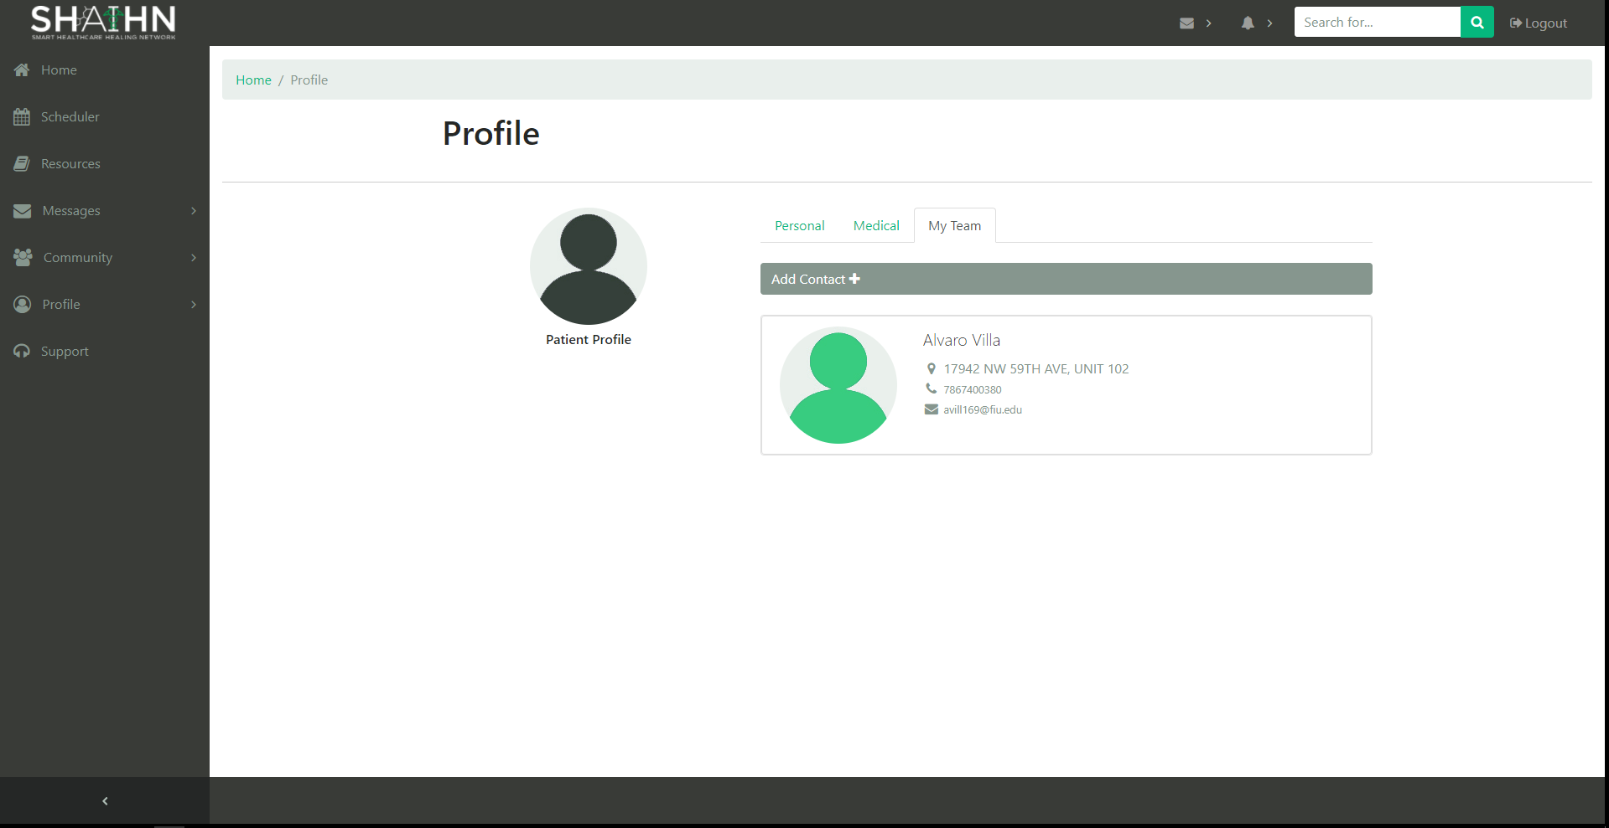

In the section My Team, users can view a list of the contacts they’ve added.

**Add Contact**

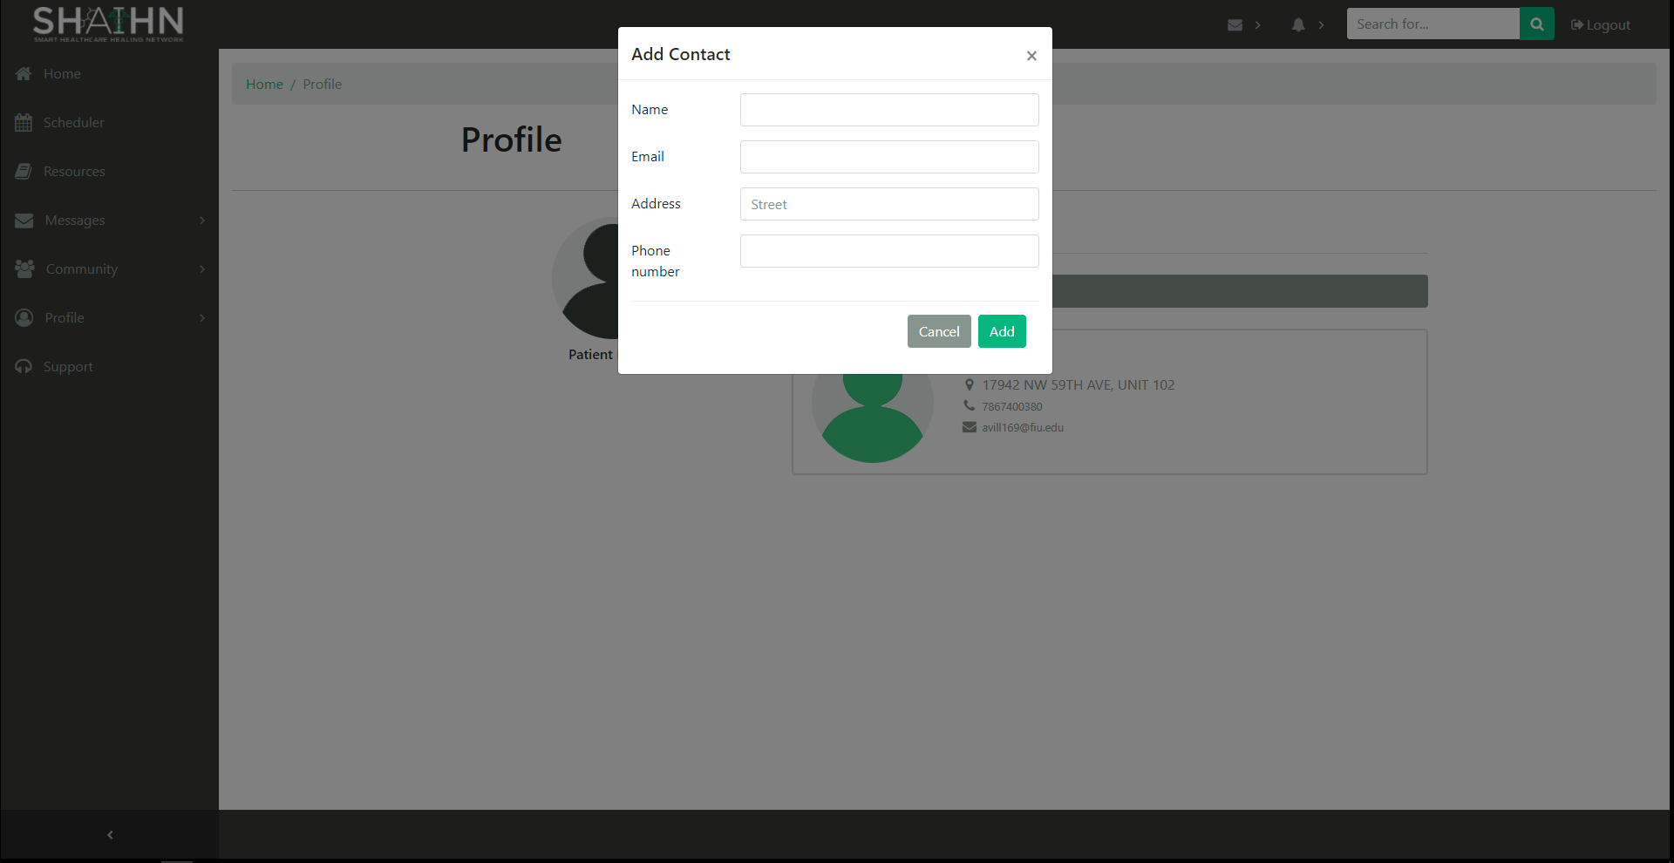

Users can add contacts by clicking the Add contact. Fill in the fields and click ‘Save Changes’.

**Support**

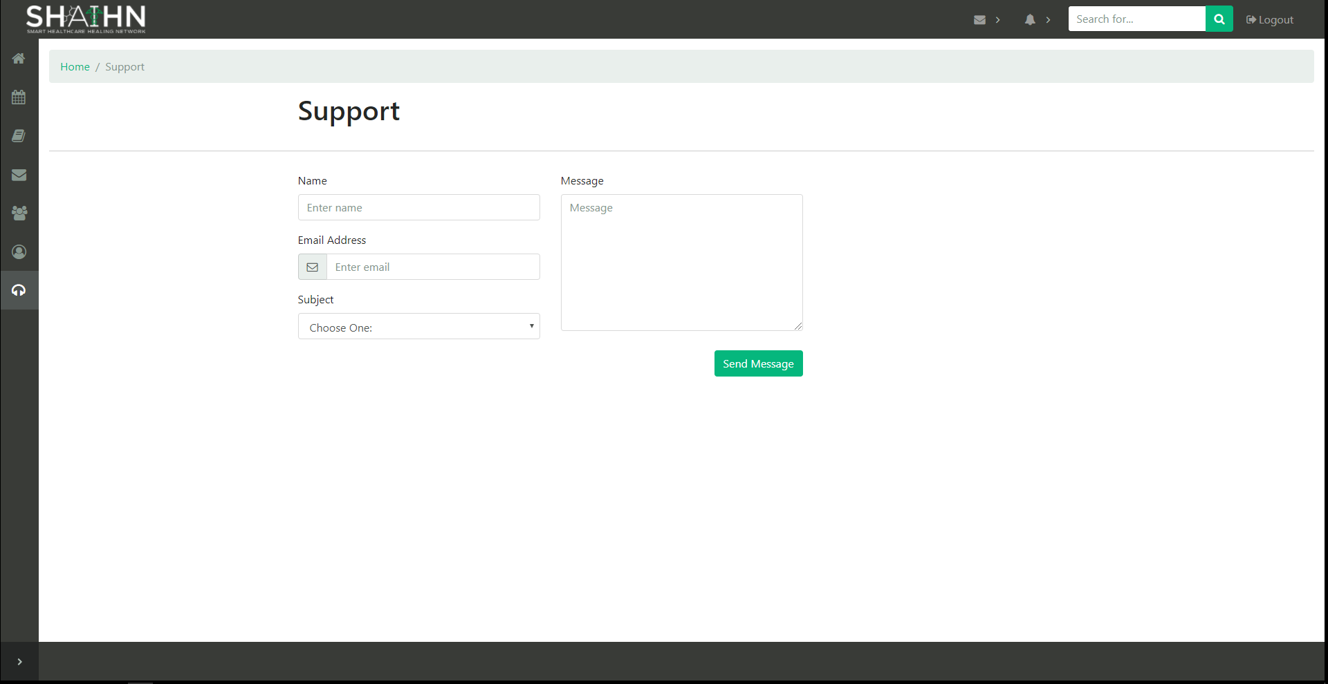

Users can send messages to the admin for any inquiries, suggestions, or any customer service related issues. (Front-end only)

**View Users (Admin)**

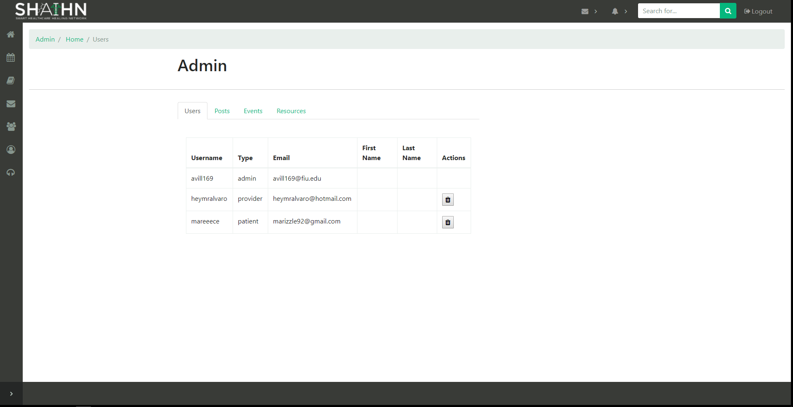

As an admin, you can view and delete users from the user collection of the database.

**View Posts (Admin)**

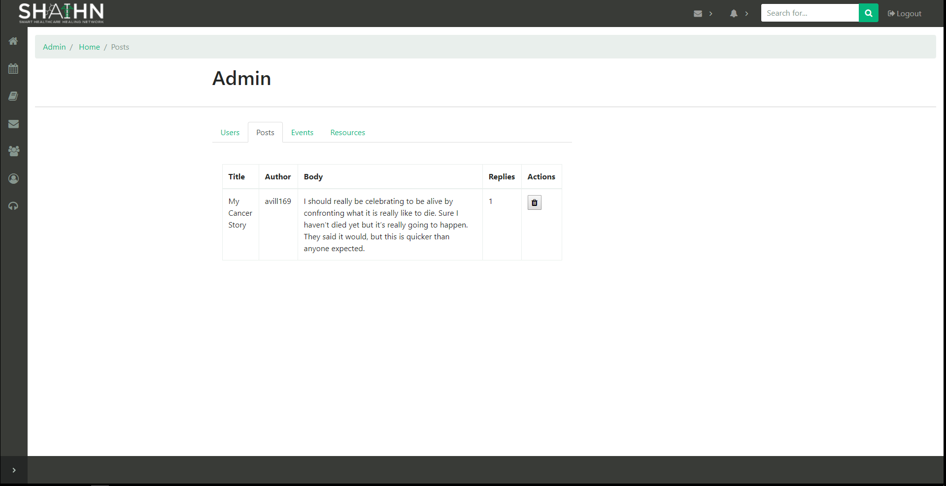

As an admin, you can view and delete posts from the post collection of the database.

**View Events (Admin)**

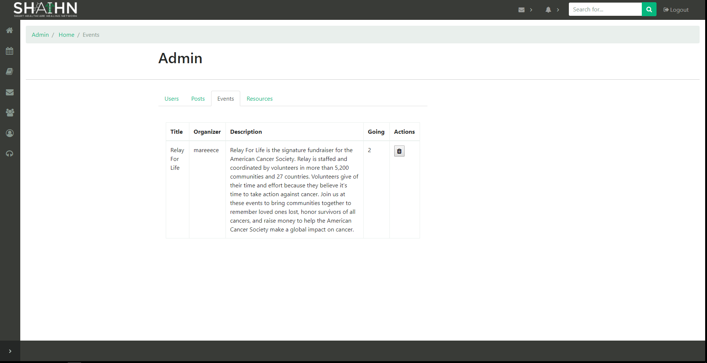

As an admin, you can view and delete events from the event collection of the database.

**View Resources (Admin)**

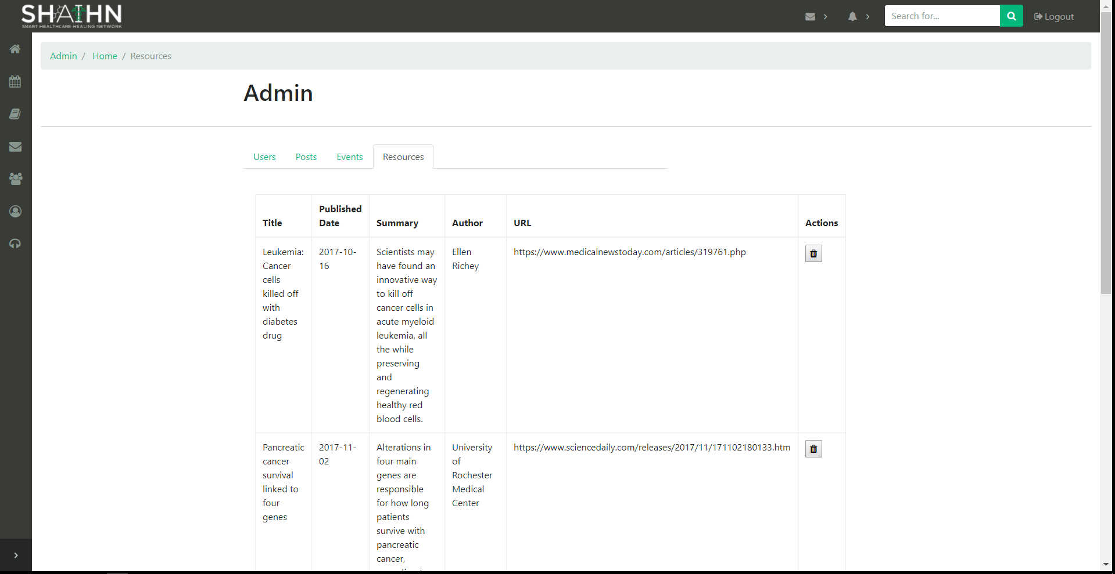

As an admin, you can view and delete resources from the resources collection of the database.

**Account Logout**

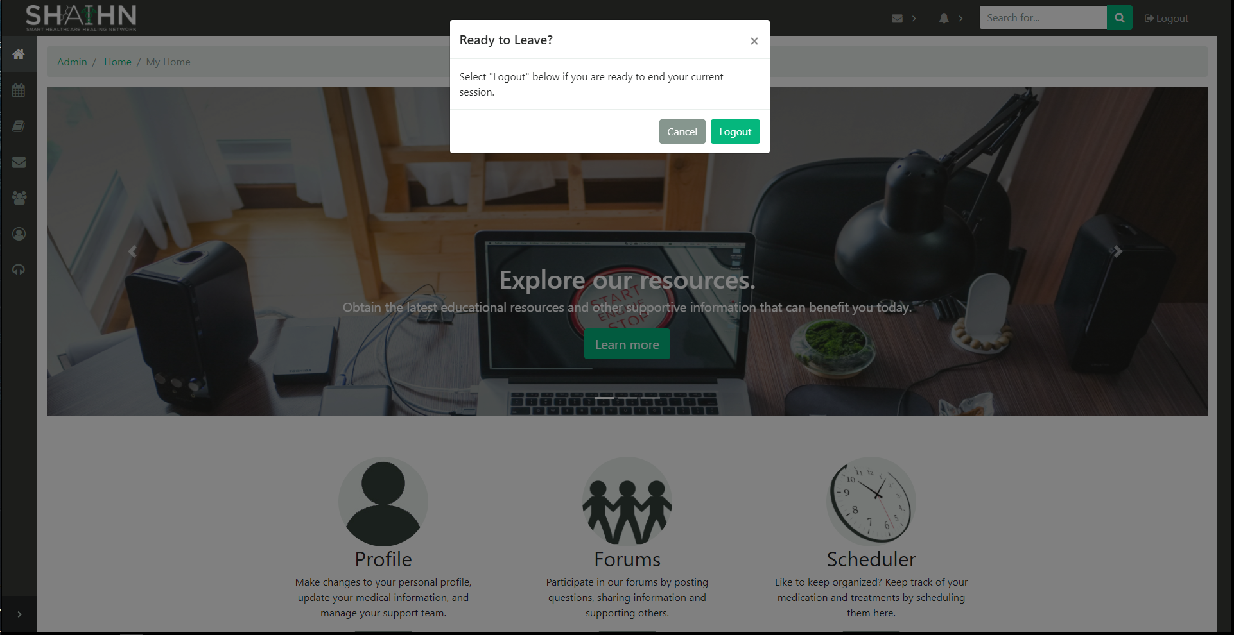

By clicking logout, you can logout of the system, and get redirected to the login page.